MASTER’S IN APPLIED ECONOMETRICS AND FORECASTING

Macroeconometrics 2

2022/2023

**The Relationship between BITCOIN and main stock market index in US: Evidence using VAR Models**

**Authors:**

Eduardo Haro, 58694

Gabriel Pereira, 58454

Maria Louro, 53554

**Professor:**

Gabriel Florin Zsurkis

Contents

1 Introduction 3

2 Literature Review 3

3 Data 5

4 Methodology 8

5 Empirical Results 9

6 Conclusions 13

7 Annexes 14

8 Bibliography 17

# Introduction

One of the most significant financial inventions of the past ten years is bitcoin. The unique quality of bitcoin is that it is a component of an entirely private monetary system; rather than relying on confidence in a central bank, it relies on the community or network of bitcoin users to validate transactions (Dowd & Hutchinson, 2015). It has gained a lot of popularity due to its unregulated nature (Blau, 2017). Although there are already over 2,000 cryptocurrencies and that number is expected to rise, none of them have attained the level of market capitalization, volume, or popularity that bitcoin has. Furthermore, the value of practically every digital currency is based on the price of bitcoin.

Following its rise in popularity, Bitcoin came to be regarded as a novel form of investment (Corbet, Meegan, Larkin, Lucey, & Yarovaya, 2018). Nonetheless, there is disagreement about how to categorize Bitcoin among experts in finance as well as in the literature. While some earlier research (Dyhrberg A. H., 2016) and (Polasik, Piotrowska, Wisniewski, Kotkowski, & Lightfoot, 2015) assert that it shares some characteristics with currencies, other research (Baur, Hong, & Lee, 2018) contends that it is a speculative asset with some distinct characteristics. Additionally, academics have recently questioned Bitcoin's ability to hedge. As with discussions surrounding Bitcoin's investment classification, earlier research on the use of Bitcoin as a hedging strategy reveals varying outcomes. Furthermore, including Bitcoin in financial portfolios may help reduce risk, according to certain studies' findings (Demir, Lau, Vigne, & Gozgor, 2018), (Guesmi, Saadi, Abid, & Ftiti, 2019) and (Katsiampa, 2017). However, it's also believed that market shocks have an impact on Bitcoin and all other financial instruments (Klein, Thu, & Walther, 2018).

Even if there have been a lot more studies on Bitcoin investment in the last ten years, we believe that there are still some areas of research that need more discussion or clarification. In this way, we make many contributions to the literature. First, the methodological technique used in our paper differs from earlier research. To demonstrate the existence of causation between variables, we use Vector Autoregressive (VAR) models. Second, we incorporate the three most popular financial markets indexes into the model: the S&P 500, Dow Jones and NASDQ Composite because they represent the most important and influential companies in the US markets. For this, the main objective of this research is to understand how external shocks in BITCOIN-USD can affect the most popular financial market indexes.

# Literature Review

Numerous recent studies addressing the topic of cryptocurrencies and capital markets have focused on understanding the genesis, behavior, and mechanism of cryptocurrencies (Inaba, 2020), (Chen, 2021), (Ilk, Guangzhi, Shaokun, & Zhao, 2021) and many Tmore. Bitcoins and financial securities are comparable, according to the pertinent literature, thus it makes sense to compare them with other financial factors. (Basher, Haug, & Sadorsky, 2012) discovered interdependence between exchange rates and the prices of stocks and oil within a vector autoregressive model with error correction. (Beniamin, 2017) discusses the function of money and counterfeit currencies. (Tschorsch & Scheuermann, 2016) examined the technological facets of bitcoin, blockchain, security, networks, and privacy.

Since the emergence of cryptocurrencies, academics have added them to the list of possible financial products. (Van Wijk, 2013) concluded that investors might set more reasonable expectations for their Bitcoin investments by having realistic expectations about the underlying financial variables. (Golez & Koudijs, 2018) draw attention to the financial literature's intense interest in the predictability of returns on financial assets. Some research' findings suggest that stock returns can be somewhat predicted (Cochrane, 2008) and (Van Binsbergen & Koijen, 2010). (Van Wijk, 2013) made note of the relationship between most factors influencing the price of Bitcoin and the US economy.

Other studies suggested that cryptocurrency price volatility is a result of market sentiment, which can be united with significative “memory” (Chea & Fry, 2015) and (Katsiampa, 2017). Based on these studies, the “memory” of cryptocurrency price shocks is the semi-important cryptocurrency price determinant. According to the results of the (Dyhrberg A. , Bitcoin, gold and the dollar – A GARCH volatility analysis, 2006a) study, bitcoin could be useful for risk-averse investors, as a negative shocks absorber, and then, in his next study, the author (Dyhrberg A. , 2016b) concludes that bitcoin can serve as a hedge against the market-specific risk. In their paper, (Malladi & Dheeriya, 2020), concluded that global stock market returns, as well as gold returns, are not a significant determinant of bitcoin returns.

Numerous studies draw comparisons between Bitcoin and other financial instruments like commodities, stock indexes, fund rates, currencies, and so forth. Studies' findings often show that Bitcoin is unaffected by conventional assets. Few studies, meanwhile, assert that these assets are related to one another. According to (Qiang, Bouri, Gupta, & Roubaud, 2018), there isn't much of a relationship between Bitcoin and other financial instruments like dollars, gold, and stocks. Additionally, they claim that Bitcoin's price fluctuations are largely autonomous. In a similar vein, (Zeng, Yang, & Shen, 2020) draw the conclusion that there is little correlation between Bitcoin and other assets.

Nonetheless, their results indicate that negative returns have a comparatively large impact on Bitcoin. According to data from the (Corbet, Meegan, Larkin, Lucey, & Yarovaya, 2018) study, there is a substantial correlation between Bitcoin and other cryptocurrencies, but they are not tied to traditional assets. By distinguishing short-term from long-term volatility, (Kurihara & Fukushima, 2018) investigate Bitcoin volatility and discover that it depends on the duration of the period. The authors also concluded that exchange rates or stock prices have no bearing on Bitcoin prices.

(Park, Jang, & Yang, 2021) show that there are interactions between Bitcoin and other financial instruments, which is in contradiction to the literature. It is found that, in contrast to other financial assets, Bitcoin is more vulnerable to exchange rate fluctuations. In a similar vein, (Bouri, Molnar, Azzi, Roubaud, & Hagfors, 2017) noted that commodities have an impact on Bitcoin and that it is not independent of other asset classes. The S&P 500 index and Bitcoin have a unidirectional link, according to (Erdas & Caglar, 2018). However, their findings demonstrate that there is no connection between Bitcoin and the dollar, gold, oil, or the BIST 100 index.

# Data

As previously mentioned, the data gathered is the prices of S&P 500 (^SPX), Dow Jones Industrial Average (^DJI), NASDAQ Composite (^IXIC) financial market indexes and BITCOIN in USD (BTC-USD). The data was obtained from 2014/09/18 until 2023/12/15 because the start date was the first time Bitcoin was reported in Yahoo Finance. However, nominal prices were not used to model the interdependencies of the previous variables but instead, log returns were calculated for the modeling phase.

There are many reasons to work with log returns. First, price series are regularly non-stationary and right skewed, for this, empirical examples suggest that working with log returns addresses the problems. Second, working with log returns helps to avoid the limited liabilities problems thar arise while working with simple returns. Third, calculating multiple period returns is much simpler working with log returns rather than simple returns. Finally, log returns are more compatible with the Random Walk Model (Dettling , 2021).

## Descriptive Statistics

Figure 1. Plots on nominal prices

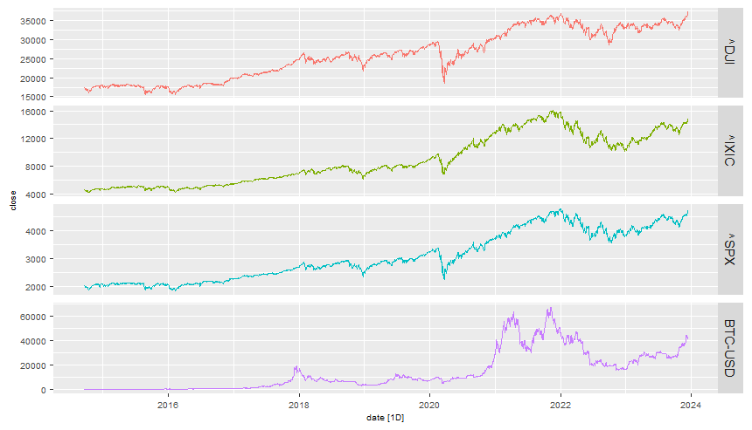

Figure 2. Plots on log returns

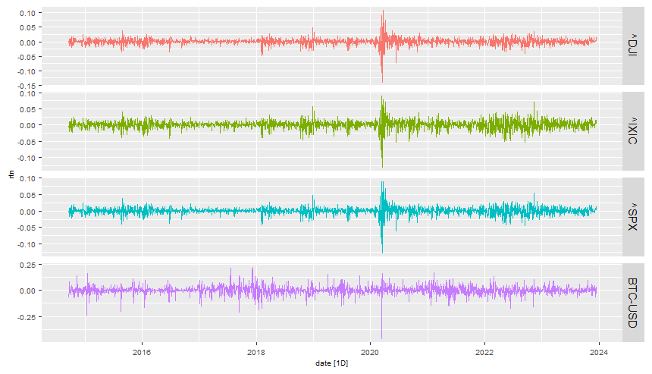

Figure 1 and Figure 2 present the nominal prices and log returns time series respectively for each variable. The first figure clearly shows a trend component while the second presumably presents a stationary behavior around 0 for time series. It is also clearly visible a decrease for nominal prices and abnormal negative log returns in 2020 due to the COVID pandemic. However, prices and log returns stabilized after this period.

Descriptive univariate statistics can be found in Table 1. Also, histograms for log returns can be found in Figure 7. Finally, a correlation table can be found in Table 2 where the three financial market indexes are highly correlated among each other, but Bitcoin is lowly correlated with the other variables.

Table 1. Descriptive univariate statistics

| symbol | *n* | min | 1stQ | mean | median | 3rdQ | max | skew | kurt |
| --- | --- | --- | --- | --- | --- | --- | --- | --- | --- |
| BTC-USD | 2,326 | -0.46 | -0.01 | 0.00 | 0.00 | 0.02 | 0.23 | -0.83 | 11.42 |
| ^DJI | 2,326 | -0.14 | -0.00 | 0.00 | 0.00 | 0.01 | 0.11 | -0.94 | 21.92 |
| ^IXIC | 2,326 | -0.13 | -0.01 | 0.00 | 0.00 | 0.01 | 0.09 | -0.63 | 8.25 |
| ^SPX | 2,326 | -0.13 | -0.00 | 0.00 | 0.00 | 0.01 | 0.09 | -0.79 | 15.44 |

Table 2. Correlation Matrix for log returns

| BTC-USD | ^DJI | ^IXIC | ^SPX |
| --- | --- | --- | --- |
| 1.00 | 0.20 | 0.24 | 0.22 |
| 0.20 | 1.00 | 0.85 | 0.96 |
| 0.24 | 0.85 | 1.00 | 0.95 |
| 0.22 | 0.96 | 0.95 | 1.00 |

# Methodology

As it was also previously mentioned, a Vector Autoregression (VAR) model will used for modeling the interdependent behavior of all variables. Following (Lütkepohl, 2005), the VAR model can be represented as

$y_{t}=v+ A_{1}*y_{t-1}+ A_{2}*y_{t-2}+…+A_{p}*y_{t-p}+u_{t }, t = 0,∓1,∓2,… ,$

where $y_{t}={\left(y_{1t},y_{2t}, …, y_{Kt}\right)}^{'}$ is a (K*1) random vector, the $A_{i}$ are fixed (K*K) coefficient matrices, $v={\left(v_{1},v_{2}, …, v_{K}\right)}^{'}$ is a fixed (K*1) vector of intercept terms allowing the possibility of a nonzero mean E($y_{t}$). Finally, $u_{t}={\left(u_{1t},u_{2t}, …, u_{Kt}\right)}^{'}$ is a K-dimensional white noise or innovation process, that has the following properties: E($u_{t}$) = 0, E($u_{t}u_{s}'$) = 0 for $s≠t$. The covariance matrix $Σ_{u}$ is assumed to be non-singular. For our research, K = 4.

Since the main interest of this project is to study the effect of external shocks in Bitcoins on the other variables, a first step is to focus on Granger Causality. The Granger Causality helps to determine if a variable is helpful to forecast another variable and its mathematical definition states that

$x_{t}$**Granger-causes $z_{t}$ iff:**

$MSE \left[E\left(z_{T+h} | z_{t},z_{t-1},…,x_{t},x_{t-1},…\right)\right]≤ MSE \left[E\left(z_{T+h} | z_{t},z_{t-1},…\right)\right]$ for some h, and

$$MSE \left[E\left(z_{T+h} | z_{t},z_{t-1},…,x_{t},x_{t-1},…\right)\right]≠ MSE \left[E\left(z_{T+h} | z_{t},z_{t-1},…\right)\right]$$

$x_{t}$**does not Granger-causes $z_{t}$ iff:**

$$MSE \left[E\left(z_{T+h} | z_{t},z_{t-1},…,x_{t},x_{t-1},…\right)\right]= MSE \left[E\left(z_{T+h} | z_{t},z_{t-1},…\right)\right]$$

Furthermore, understanding the causal relationship between changes in one variable and changes in another, while maintaining the same values for all other variables, is of great importance in empirical research. With VAR models, this analysis is mostly done with Impulse Response Functions (IRF). An IRF measures the effect (or variation) of a variable to a ceteris paribus shock or impulse of certain magnitude in other variable for h periods after the shock occurrence.

The IRF can be obtained from the VMA coefficient matrices derived from the VAR. In particular, element (j,k) of matrix $Φ_{i}$ represents the response of variable j to a unit shock in variable k, after i periods. The VMA representation of the system is

$$y_{t}=μ+I_{K}*u_{t}+ ϕ_{1}*u_{t-1}+ ϕ_{2}*u_{t-2}+…$$

and the accumulated IRF over n periods can be obtained from:

$$Ψ_{n}= \sum_{i=0}^{n}{ϕ_{i}}$$

and the long-run effects measure the total accumulated effects for all future periods and is given by

$$Ψ_{∞}= \sum_{i=0}^{∞}{ϕ_{n}}= ϕ\left(1\right)={(I_{K}-A_{1}-A_{2}-…-A_{p} )}^{-1}$$

However, it is difficult to relate directly $u_{i,t}$ to a ceteris paribus shock in variable i because $u_{t}$ are, in general, not independent. Hence, it does not represent forces that affect one variable only. In fact, they represent combinations of different forces that may affect any variable included in the VAR. For this, a different representation of the VAR model is used where innovations are at least uncorrelated is used using the Choleski Decomposition at $Σ_{u}$.

The Choleski Decomposition states that if $Σ$ is a positive definite matrix, then there exists, at least, a lower triangular matrix W and a diagonal matrix D such that:

$$Σ=WDW^{'}↔ Σ={PP}^{'}with P=W*D^{1/2}$$

the decomposition is unique if W has 1s along the diagonal. The new WMA representation with $e_{t}$ is:

$$y_{t}=Θ_{0}*e_{t}+ Θ_{1}*e_{t-1}+ Θ_{2}*e_{t-2}+…$$

where $Θ_{i}= ϕ_{i}P$, $e_{t-i}= P^{-1}u_{t-1}$ and $Σ_{u}=E\left(e_{t}e_{t}^{'}\right)= I_{k}$.

# Empirical Results

Before conducting a VAR estimation, a unit root analysis was performed on the log returns of the variables. The stationarity of the variables was performed using Augmented Dickey Fuller (ADF) Test. The test was performed assuming a no drift and no trend scenario with 1 lag. Results can be found in Table 3. This result suggests that there is no unit root in the variables.

Table 3. ADF Tests

|  |  |  |
| --- | --- | --- |
| Variable | Test Statistic | p-value |
| BTC-USD | -34.4 | 0.01 |
| ^DJI | -33.1 | 0.01 |
| ^IXIC | -34.3 | 0.01 |
| ^SPX | -33.9 | 0.01 |

Furthermore, the next step in the model’s identification process is to determine the number of lags the VAR model. For this, different information criterion was estimated yielding the results in Table 4 where the numbers in the first row are the number of lags. Results for the AIC criterion suggests the use of 9 lags while the HQ and SC criterion suggest using 1 lag. However, due to the diverse results in for the selection criterion, different lag values were proposed, and a lag 4 VAR model was selected for its good post-estimation results.

Table 4. Information criterion for lag selection

| **Criterion** | 1 | 2 | 3 | 4 | 5 | 6 | 7 | 8 | 9 | 10 |
| --- | --- | --- | --- | --- | --- | --- | --- | --- | --- | --- |
| **AIC(n)** | -38.46 | -38.47 | -38.48 | -38.48 | -38.48 | -38.48 | -38.50 | -38.51 | **-38.51\*** | -38.51 |
| **HQ(n)** | **-38.44\*** | -38.44 | -38.43 | -38.42 | -38.40 | -38.39 | -38.40 | -38.39 | -38.38 | -38.36 |
| **SC(n)** | **-38.41\*** | -38.38 | -38.35 | -38.31 | -38.27 | -38.24 | -38.22 | -38.18 | -38.14 | -38.10 |

Estimation results for the VAR coefficients can be found in Table 10. After this, a Granger Causality Test was performed to understand better the direction of the variables, results can be found in Table 11. For our purposes, it is noteworthy to mention that none of the financial market indexes granger cause Bitcoin, but Bitcoin does granger cause the Dow Jones and S&P 500 indexes. Moreover, a Breusch-Godfrey LM Test was performed on the residuals of the VAR model to test the presence of autocorrelation. Results can be found in Table 5 where there is no sign of first-order autocorrelation.

Table 5. Breusch-Godfrey LM Test for 1st order autocorrelation

|  |  |  |
| --- | --- | --- |
| chi-squared | df | p-value |
| 19.47 | 16 | 0.245 |

Other diagnostic tests were performed to the VAR model. First, a normality test was performed on the residuals and the results can be found in Table 6. The residuals are not normally distributed.

Table 6. Normality tests on the VAR residuals

|  |  |  |  |
| --- | --- | --- | --- |
|  | chi-squared | df | p-value |
| JB-Test | 28694 | 8 | <2e-16 |
| Skewness | 578.8 | 4 | <2e-16 |
| Kurtosis | 28115 | 4 | <2e-16 |

Also, an ARCH dynamics test was also performed on the residuals and results can be found in Table 7. Unfortunately, the VAR model has at least ARCH dynamics on the residuals. These results do not invalidate the consistency of the VAR coefficients, but it interferes with the efficiency of the estimators and statistical inference on, for example, impulse response functions.

Table 7. ARCH tests on VAR residuals

|  |  |  |  |
| --- | --- | --- | --- |
| lags | chi-squared | df | p-value |
| 1 | 1711 | 100 | <2e-16 |
| 2 | 2799 | 200 | <2e-16 |
| 3 | 3708 | 300 | <2e-16 |
| 4 | 4035 | 400 | <2e-16 |

Finally, a structural break analysis was performed to determine if any of the variables may have a structural break. Figure 3 suggests there is no structural break in the any of the variables.

Figure 3. Structural Break OLS-Cumsum graphs for all variables

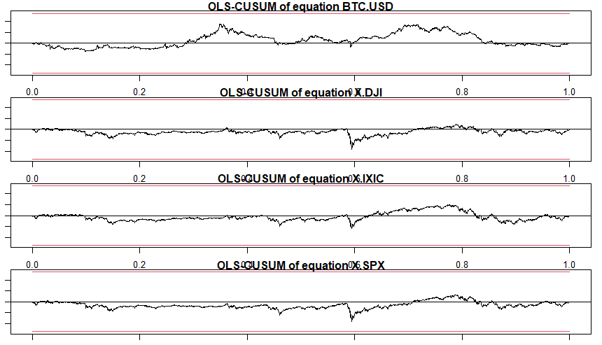

The previous diagnostic tests suggests that the VAR model is correctly specified, except for the ARCH dynamics which can interfere with inferential results. This problem will be later addressed for the IRF. Since the main objective of this research is to identify the effect of Bitcoin in the three market indexes, a Structural VAR methodology where innovations are uncorrelated is implemented, where the most exogeneous variable is BITCOIN because the Granger Causality test suggests none of the other variables granger cause bitcoin. Estimation results for the A and B matrices can be found in Table 8 and Table 9 where the A matrix models the dynamics between the changes of variables on others and the B matrix models the dynamics of changes of variables on itself.

Table 8. A-matrix for SVAR model

|  |  |  |  |  |
| --- | --- | --- | --- | --- |
|  | BTC-USD | ^DJI | ^IXIC | ^SPX |
| BTC-USD | 1 |  |  |  |
| ^DJI | -0.05447 | 1 |  |  |
| ^IXIC | -0.02492 | -1.003 | 1 |  |
| ^SPX | 0.00148 | -0.569 | -0.398 | 1 |

Table 9. B-matrix for SVAR model

|  |  |  |  |  |
| --- | --- | --- | --- | --- |
|  | BTC-USD | ^DJI | ^IXIC | ^SPX |
| BTC-USD | 0.0404 |  |  |  |
| ^DJI | 0 | 0.0109 |  |  |
| ^IXIC | 0 | 0 | 0.00705 |  |
| ^SPX | 0 | 0 | 0 | 0.00139 |

Impulse Response Functions were estimated on the Structural VAR in Figure 4, Figure 5 and Figure 6. Due to the ARCH dynamics of the VAR model, the confidence intervals for the estimates can were calculated using bootstrap methodology for more reliability.

Figure 4. IRF from Bitcoin to Dow Jones Industrial Average

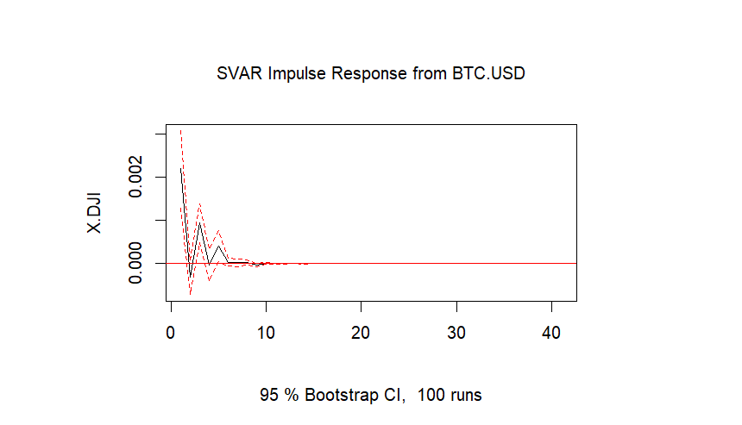

Figure 5. IRF from Bitcoin to NASDAQ Composite

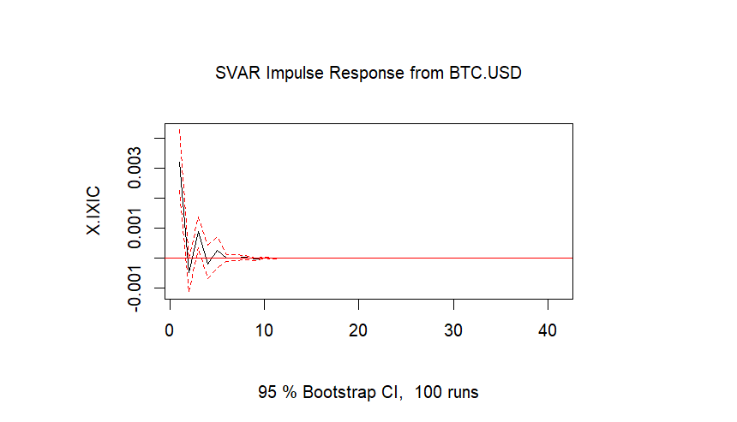

Figure 6. IRF from Bitcoin to S&P 500

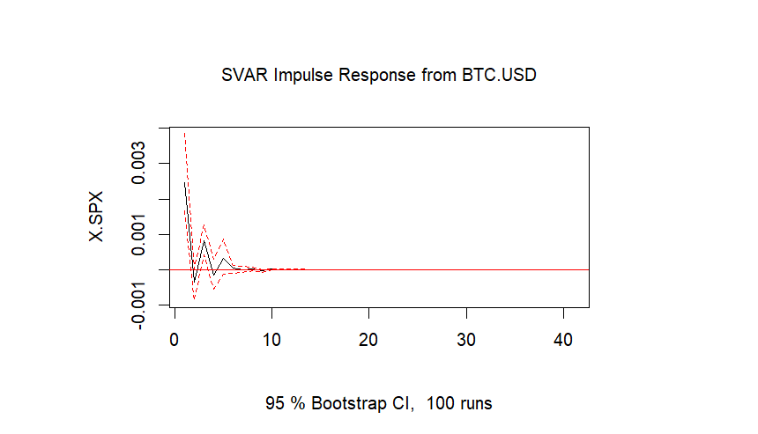

The IRF show that the exogenous effects on Bitcoin have a small impact on the three most popular market indexes. Shocks in Bitcoin’s log returns have a small and short effect in Financial Markets that disappears in the long run.

# Conclusions

# Annexes

Figure 7. Histograms of log returns

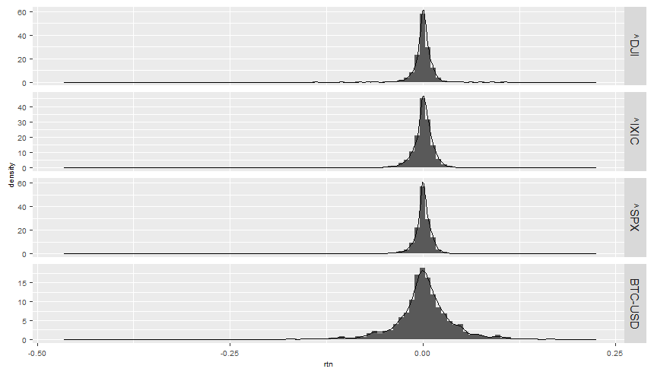

Table 10. VAR estimation results for each variable

| **Coef.** | **BTC** | **^DJI** | **^IXIC** | ^**SPX** |
| --- | --- | --- | --- | --- |
| BTC.USD.L1 | 0.00 | -0.00 | -0.00 | -0.00 |
| X.DJI.L1 | 0.34 | 0.04 | -0.02 | 0.00 |
| X.IXIC.L1 | 0.29 | 0.23** | 0.21* | 0.20** |
| X.SPX.L1 | -0.81 | -0.43* | -0.36. | -0.36* |
| BTC.USD.L2 | -0.01 | 0.02** | 0.02** | 0.02** |
| X.DJI.L2 | 0.19 | 0.32** | 0.18 | 0.29** |
| X.IXIC.L2 | 0.01 | 0.06 | -0.04 | 0.02 |
| X.SPX.L2 | -0.13 | -0.30. | -0.07 | -0.23 |
| BTC.USD.L3 | 0.04* | 0.00 | -0.00 | -0.00 |
| X.DJI.L3 | -0.13 | 0.26* | 0.27* | 0.27** |
| X.IXIC.L3 | -0.19 | 0.19** | 0.13 | 0.18* |
| X.SPX.L3 | 0.33 | -0.47** | -0.41* | -0.46** |
| BTC.USD.L4 | 0.03 | 0.01. | 0.01 | 0.01 |
| X.DJI.L4 | -0.26 | 0.03 | -0.07 | -0.03 |
| X.IXIC.L4 | -0.05 | 0.12 | 0.04 | 0.08 |
| X.SPX.L4 | 0.21 | -0.23 | -0.03 | -0.13 |
| Cons | 0.00. | 0.00 | 0.00. | 0.00 |

Signif. codes: 0 ‘***’ 0.001 ‘**’ 0.01 ‘*’ 0.05 ‘.’ 0.1 ‘

Table 11. Granger Causality Estimation Results

| Equation | Excluded | *F* | df1 | df2 | p.F | sig.F | Chisq | *df* | p.Chisq | sig.Chisq | Causality |
| --- | --- | --- | --- | --- | --- | --- | --- | --- | --- | --- | --- |
| BTC.USD | X.DJI | 0.45 | 4.00 | 2,305.00 | 0.77 |  | 1.81 | 4 | 0.77 |  | BTC.USD <= X.DJI |
| BTC.USD | X.IXIC | 0.46 | 4.00 | 2,305.00 | 0.77 |  | 1.84 | 4 | 0.77 |  | BTC.USD <= X.IXIC |
| BTC.USD | X.SPX | 0.59 | 4.00 | 2,305.00 | 0.67 |  | 2.38 | 4 | 0.67 |  | BTC.USD <= X.SPX |
| BTC.USD | ALL | 0.83 | 12.00 | 2,305.00 | 0.62 |  | 9.99 | 12 | 0.62 |  | BTC.USD <= ALL |
| X.DJI | BTC.USD | 3.37 | 4.00 | 2,305.00 | 0.01 | ** | 13.49 | 4 | 0.01 | ** | X.DJI <= BTC.USD |
| X.DJI | X.IXIC | 4.83 | 4.00 | 2,305.00 | 0.00 | *** | 19.34 | 4 | 0.00 | *** | X.DJI <= X.IXIC |
| X.DJI | X.SPX | 4.89 | 4.00 | 2,305.00 | 0.00 | *** | 19.56 | 4 | 0.00 | *** | X.DJI <= X.SPX |
| X.DJI | ALL | 3.41 | 12.00 | 2,305.00 | 0.00 | *** | 40.88 | 12 | 0.00 | *** | X.DJI <= ALL |
| X.IXIC | BTC.USD | 1.97 | 4.00 | 2,305.00 | 0.10 | . | 7.89 | 4 | 0.10 | . | X.IXIC <= BTC.USD |
| X.IXIC | X.DJI | 1.88 | 4.00 | 2,305.00 | 0.11 |  | 7.51 | 4 | 0.11 |  | X.IXIC <= X.DJI |
| X.IXIC | X.SPX | 1.86 | 4.00 | 2,305.00 | 0.11 |  | 7.45 | 4 | 0.11 |  | X.IXIC <= X.SPX |
| X.IXIC | ALL | 4.39 | 12.00 | 2,305.00 | 0.00 | *** | 52.73 | 12 | 0.00 | *** | X.IXIC <= ALL |
| X.SPX | BTC.USD | 2.55 | 4.00 | 2,305.00 | 0.04 | * | 10.18 | 4 | 0.04 | * | X.SPX <= BTC.USD |
| X.SPX | X.DJI | 3.72 | 4.00 | 2,305.00 | 0.01 | ** | 14.87 | 4 | 0.00 | ** | X.SPX <= X.DJI |
| X.SPX | X.IXIC | 3.39 | 4.00 | 2,305.00 | 0.01 | ** | 13.57 | 4 | 0.01 | ** | X.SPX <= X.IXIC |
| X.SPX | ALL | 3.82 | 12.00 | 2,305.00 | 0.00 | *** | 45.84 | 12 | 0.00 | *** | X.SPX <= ALL |

# Bibliography

Basher, S., Haug, A., & Sadorsky, P. (2012). Oil prices, exchange rates and emerging stock markets. *Energy Economics*, 227-240.

Baur, D., Hong, K., & Lee, A. (2018). Bitcoin: Medium of exchange or speculative assets? *Journal of International Financial Markets. Institutions and Money*, 177-189.

Beniamin, N. (2017). Traditional and modern forms of money: euro. *Czech Journal of Social Sciences Business*, 22-30.

Blau, B. (2017). Price dynamics and speculative trading in Bitcoin. *Research in International Business and Finance*, 493-499.

Bouri, E., Molnar, P., Azzi, G., Roubaud, D., & Hagfors, L. (2017). On the hedge and safe haven properties of Bitcoin: Is it really more than a diversifier? *Finance Research Letters*, 192-198.

Chea, E.-T., & Fry, J. (2015). Speculative bubbles in Bitcoin markets? An empirical investigation into the fundamental value of Bitcoin. *Economics Letters*, 32-36.

Chen, Y. (2021). Empirical analysis of bitcoin price. *Journal of Economics and Finance*, 692–671.

Cochrane, J. (2008). The Dog That Did Not Bark: A Defense of Return Predictability. *Review of Financial Studies*, 1533-1575.

Corbet, S., Meegan, A., Larkin, C., Lucey, B., & Yarovaya, L. (2018). Exploring the dynamic relationships between cryptocurrencies and other financial assets. *Economics Letters*, 28-34.

Demir, E., Lau, M., Vigne, S., & Gozgor, G. (2018). Does economic policy uncertainty predict the Bitcoin returns? An empirical investigation. *Finance Research Letters*, 145-149.

Dettling , M. (2021). *Statistical Analysis of Financial Data.* Zurich: Zurich University of Applied Sciences. Retrieved from https://ethz.ch/content/dam/ethz/special-interest/math/statistics/sfs/Education/Advanced%20Studies%20in%20Applied%20Statistics/course-material-1921/FinancialData/Script_v210113.pdf

Dowd, K., & Hutchinson, M. (2015). Bticoin will be the dust. *Cato Journal* , 357-382.

Dyhrberg, A. (2006a). Bitcoin, gold and the dollar – A GARCH volatility analysis. *Finance Research Letters*, 85-92.

Dyhrberg, A. (2016b). Hedging capabilities of bitcoin. Is it the. *Finance Research Letters*, 85-92.

Dyhrberg, A. H. (2016). Hedging capabilities of bitcoin. Is it the virtual gold? *Finance Research Letters*, 139-144.

Erdas, M., & Caglar, A. (2018). Analysis of the relationships between Bitcoin and exchange rate, commodities and global indexes by asymmetric causality test. *Eastern Journal of European*, 27-45.

Golez, B., & Koudijs, P. (2018). Four centuries of return predictability. *Journal of Financial Economics*.

Guesmi, K., Saadi, S., Abid, I., & Ftiti, Z. (2019). Portfolio diversification with virtual currency: Evidence from bitcoin. *International Review of Financial Analysis*, 431-437.

Ilk, N., Guangzhi, S., Shaokun, F., & Zhao, J. (2021). Stability of Transaction Fees in Bitcoin: A Supply and Demand Perspective. *Management Information Systems Quaterly*, 563-592.

Inaba, K.-I. (2020). A global look into stock market comovements. *Review of World Economics*, 517-55.

Katsiampa, P. (2017). Volatility estimation for Bitcoin: A comparison of GARCH models. *Economics Letters*, 3-6.

Klein, T., Thu, H., & Walther, T. (2018). Bitcoin is not the New Gold–A comparison of volatility, correlation, and portfolio performance. *International Review of Financial Analysis*, 105-116.

Kurihara, Y., & Fukushima, A. (2018). How Does Price of Bitcoin Volatility Change? *International Research in Economics and Finance*, 8-14.

Lütkepohl, H. (2005). *New Introduction to Multiple Time Series Analysis.* Springer Link.

Malladi, R., & Dheeriya, P. (2020). Time series analysis of Cryptocurrency returns and volatilities. *Journal of Economics and Finance*, 75-94.

Park, S., Jang, K., & Yang, J.-S. (2021). Information flow between bitcoin and other financial assets. *Physica A: Statistical Mechanics and its Applications*.

Polasik, M., Piotrowska, A., Wisniewski, T., Kotkowski, R., & Lightfoot, G. (2015). Price Fluctuations and the Use of Bitcoin: An Empirical Inquiry. *International Journal of Electronic*, 9-49.

Qiang, J., Bouri, E., Gupta, R., & Roubaud, D. (2018). Network causality structures among Bitcoin and other financial assets: A directed acyclic graph approach. *The Quaterly Review of Economics and Finance*, 203-213.

Tschorsch, F., & Scheuermann, B. (2016). Bitcoin and Beyond: A Technical Survey on Decentralized Digital Currencies. *IEEE Communications Surveys & Tutorials*, 2084–2123.

Van Binsbergen, J., & Koijen, R. (2010). Predictive Regressions: A Present-Value Approach. *The Journal of Finance*, 1439-1471 .

Van Wijk, D. (2013). What can be expected from the Bitcoin? *Business Economics*.

Zeng, T., Yang, M., & Shen, Y. (2020). Fancy Bitcoin and conventional financial assets: Measuring market integration based on connectedness networks. *Economic Modelling*, 209-220.